**Business Requirements Document (BRD) Gathering Template**

1. **Business Process Mapping**

*Conduct a business process modeling activity for 1 main process of your product. Include the current state and future state with a separate diagram for each. You can use any tool to generate a graphical representation of the flow of work. Don’t forget to depict the usage and interaction between the various components – people, hardware and software.*

**As-Is (Current) Business Process Flow:**

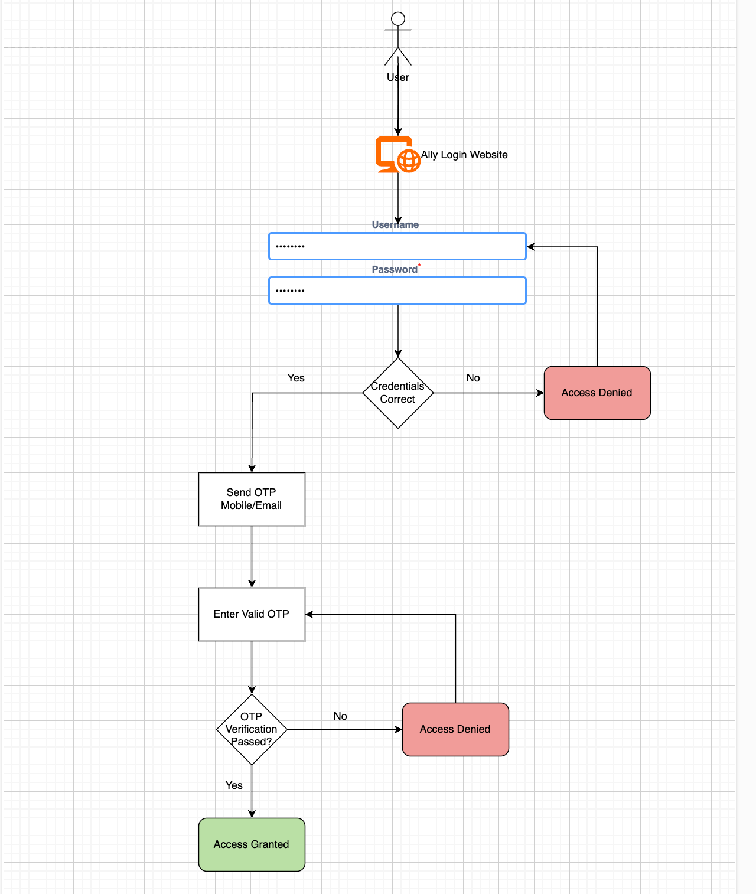

**Future (Proposed) Business Process Flow:**

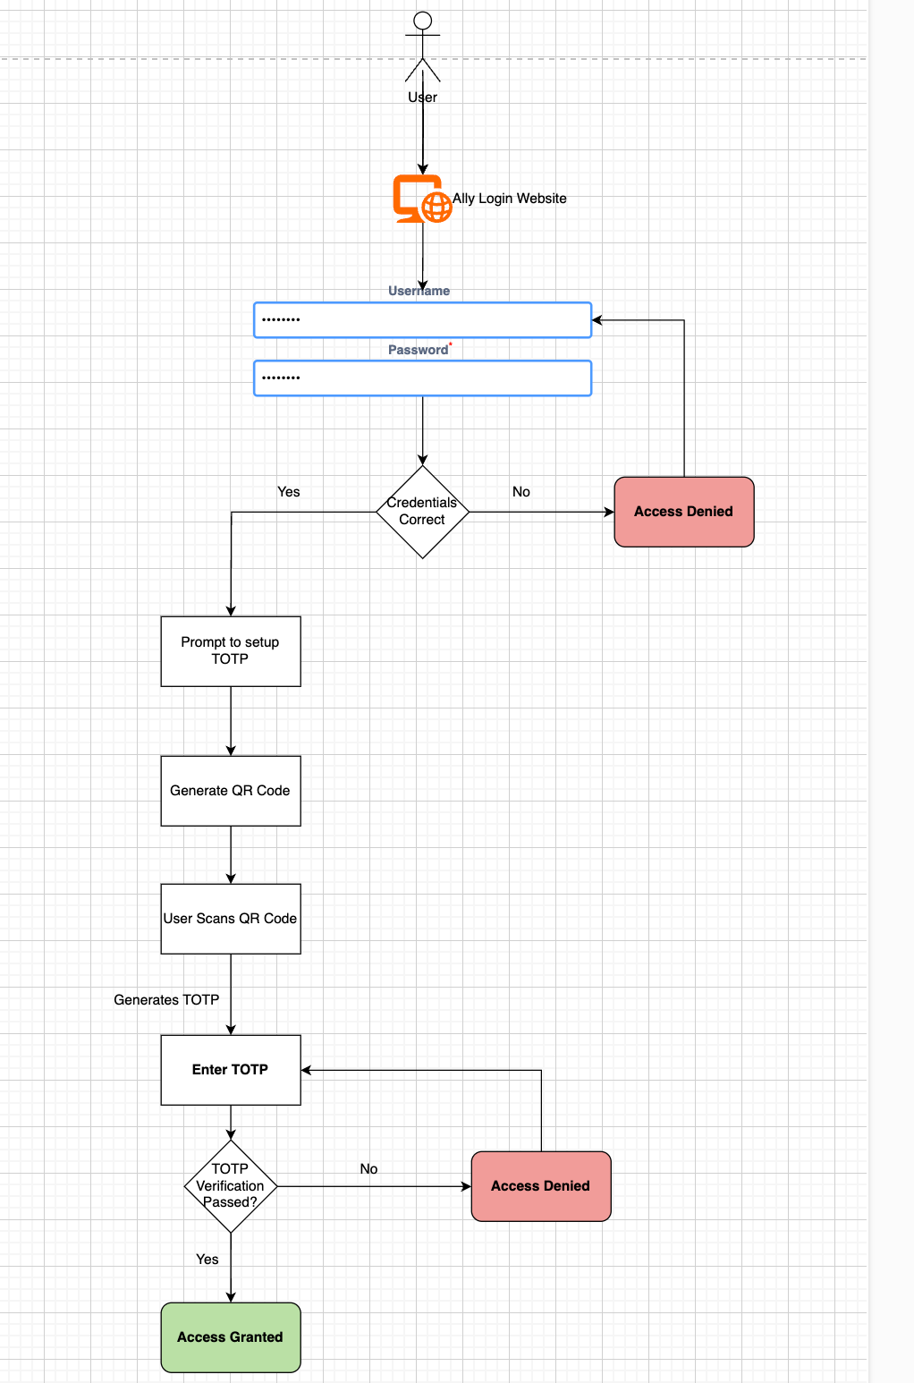

1. **Business Requirements**

*List the various requirements for your project. Include both the functional as well as the technical requirements.*

**Functional Requirements**

|  |  |
| --- | --- |
| **Functional Requirement** | **Description** |
| **Customer Login** | Users need to log in using their username and password. |
| **QR Code Generation** | The system must generate a secure QR code for users to set up TOTP |
| **Secret Key Generation** | The system must generate a secure secret code for users to set up TOTP |
| **Backup code** | The system must generate a backup code during TOTP setup |
| **Time-Based One-Time Password Authentication** | Users must enter a time-based OTP generated by Authenticator for secure login. |
| **Customer TOTP Setup Guide** | Provide a detailed user guide for set up and usage of the TOTP system. Downloadable file, it must make sure to start download the pdf. |
| **Loss of TOTP Authenticator** | Users should be able to log in using backup codes if they lose their access to authenticator |

**Technical Requirements**

|  |  |
| --- | --- |
| **Technical Requirement** | **Description** |
| **MariaDB** | User authentication data must be securely stored in MariaDB with encryption. |
| **Flask** | Flask is a lightweight Python web framework that simplifies building web applications with useful tools and features. |
| **Python** | Programming Python must handle authentication logic, user data processing, and API integration. |
| **HTML, CSS & JavaScript** | The user interface must be developed using HTML and CSS for a smooth experience. |
| **RHEL** | RHEL OS is used for performing all tasks such as creation and execution of scripts, backend server, and so on. |
| **Authy** | It is an Authenticator, used for TOTP generation and secure login. |
| **Apache** | Apache HTTP Server to host the web application securely. |
| **Microsoft Word** | Word for preparing weekly assignments, lessons learned and the TOTP setup guide. |
| **Microsoft Excel** | Excel Workbook for manual testing and documentation. |